**Activity 23**

**NAME : Shalini devi.M COURSE : Mobile Computing**

**Reg No : 192421351 COURSE CODE: ITA0302**

23. Develop a user interface prototype in Figma showcasing security measures for a mobile app. Emphasize the intuitive design for user personalization.

**Aim:**

Developing a user interface prototype in Figma showcasing security measures for a mobile app.

**Procedure:**

1. Define Presentation Structure
2. Create a Figma Project
3. Design Visual Elements
4. Make it Interactive
5. Add Annotations and Explanations
6. Incorporate Multimedia
7. Storyboard Animation
8. Test the Prototype
9. Collaborate and Gather Feedback
10. Finalize and Share

**Design:**

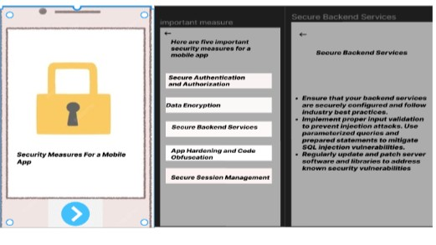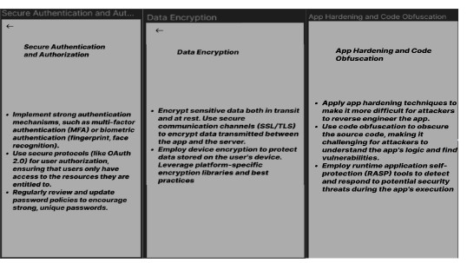

**Prototype:**

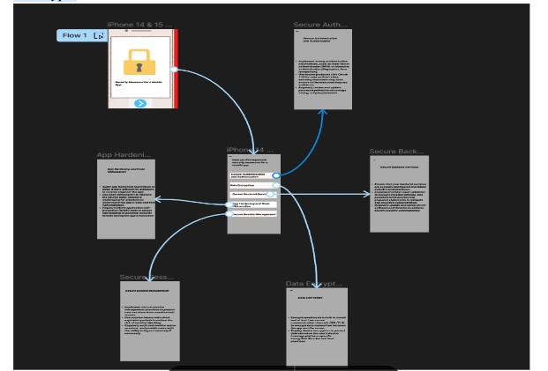

**Result**:

Hence an user interface prototype in Figma showcasing security measures for a mobile app have been created successfully